**Programming Assignment # 8 due 04/11/2016**

Build an app for a store that delivers breakfast items on our campus. Name your app as “MyStore”. The items and their unit prices are as follows:

Dasani Water (Dasani) $2.00

Fruit Maple Oatmeal (Fruit Oatmeal) $2.00

Hotcakes (Hotcakes) $2.00

Sausage Biscuit (Sausage Biscuit) $1.99

Bacon Egg Biscuit (Bacon Egg Biscuit) $2.00

Egg Sausage Biscuit (Egg Sausage) $2.00

Sausage Burrito (Burrito) $1.75

The item names in parenthesis are used in the initial menu listing of your app as shown in Figure 1 and Figure 2. The pictures needed for the ‘ButtonImage’ objects in your .xml file are provided as a zip file at Lessons->SamplePrograms->Programming Assignment 8 (Pictures). When a user presses an image button, your app should launch an intent to accept a quantity and display a list of items prior to the current selection which starts of initially as an empty list as shown in Figure 3 and Figure 4. When the order is complete and the user presses the ‘Process Order’ button your app should launch an intent that displays the ordered items with price, sub-total, tax, and total as show in Figure 5. You may assume the tax is 8.25% of the total purchase.

**Steps to turn in your assignment:**

1. Compress (zip) your project folder using Linux/Windows file compression utility and name your compressed file as your_last_name_08.zip. Log on to WTCLASS
2. Click on ‘2016SP_CS_3303_01_Object-Oriented Software Development’
3. Click on the left side item ‘Lessons’. (The remaining steps are to upload your archived work into the drop box.)
4. On the right side item under ‘Lessons,’ click on ‘Assignments (Dropbox) ->Programming Assignment 8.’
5. Click on ‘Browse’ and point to your achieved file ‘your_lastname_08.zip’ (in step 1) and then click ‘Open.’ Next click ‘Upload File’ and wait for the remote server to upload your work. Then click ‘Finished.’
6. Click ‘Submit.’ Now you will get the message on the screen “Your submission has been received successfully.”

Note: After you submit your work, please click on ‘Download’ and verify your submission for its content.

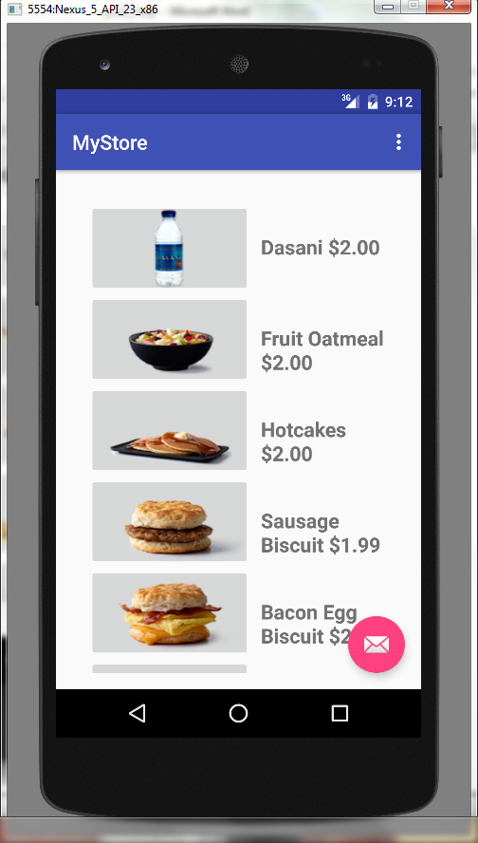

Figure 1

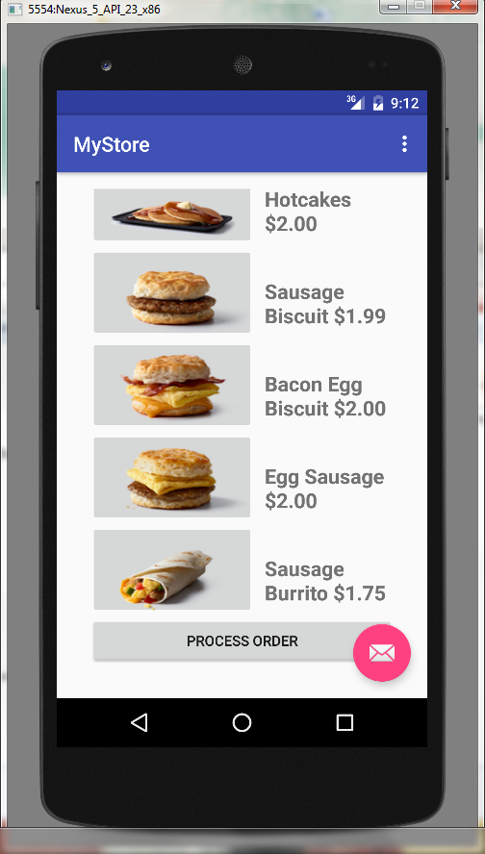

Figure 2 (Initial display after scroll down)

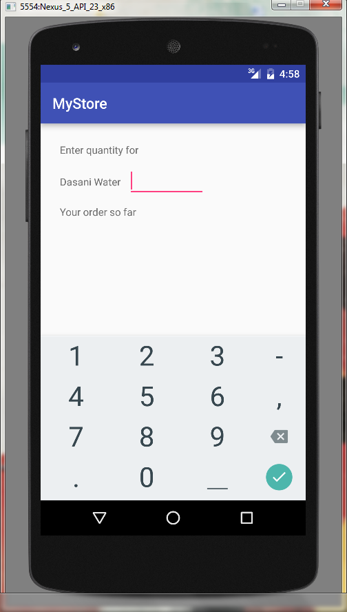

Figure 3

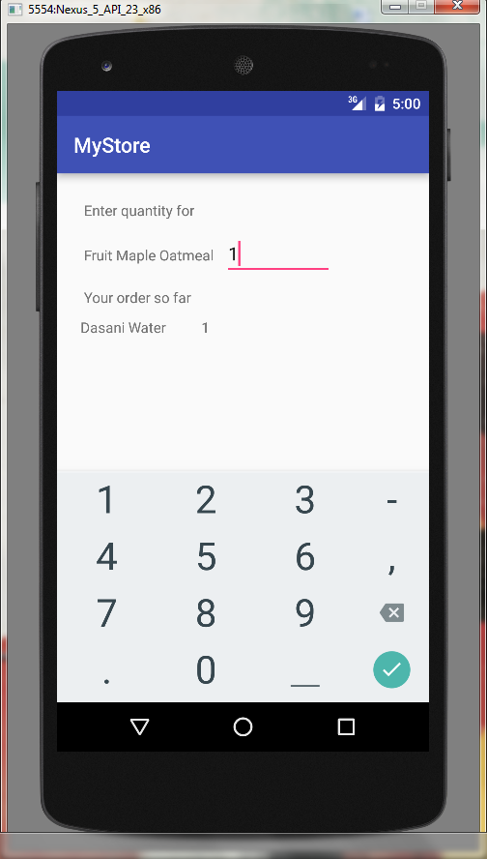

Figure 4 (After an item was previously added)

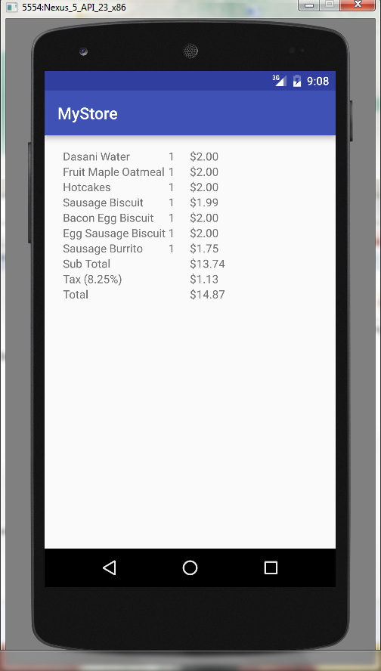

Figure 5